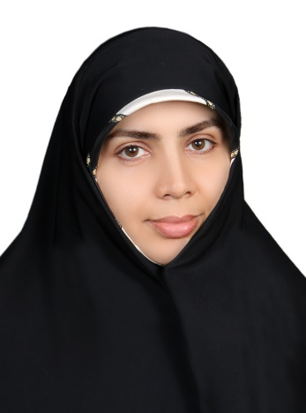

**Susan Ghaffaryan Khayyati**

**Head of the English Language Department**

**University of Religions and Denominations**

**Phone: +982531711699**

**Email:** [**s.ghaffaryan@urd.ac.ir**](mailto:s.ghaffaryan@urd.ac.ir)

* Susan Ghaffaryan got her BA in Quranic Science from Maa’ref University in Qom, Iran. She got her MA in TEFL (Teaching English as a Foreign Language) from the University of Kashan, Iran and her PhD in Applied Linguistics from Allameh Tabataba’i University of Tehran, Iran (year 2020).
* She has taught English as an International Language in different universities in Iran as well as International Islamic centers in Iran.
* She has coauthored several international papers with authors from Italy and Spain.
* She has become a faculty member in University of Religions and Denominations (URD) since 2022. And since then, she has worked as the Head of Research center at the Vice-Presidency of the International Affairs in URD (2022-2023) and Head of the English Language Department since then.
* She speaks Persian, can speak English very well and Arabic at intermediate level.
* She has got certifications in using various AI platforms for writing Academic papers.
* Her areas of interest are CDA (Critical Discourse Analysis) with a special focus on Metaphorical Analysis in Intercultural Studies, Interfaith Dialogue, as well as similar Metaphysical (Quantumic) Mysticism manifested in a vast spectrum of belief systems.